**INSURANCE BROKER MANAGEMENT SYSTEM REPORT**

**J2EE Web Components**

**ITE-5332-0NA**

**Table of Contents**

Contents

**Table of Contents** 2

1. Introduction 2

1.1 Project Overview 2

1.2 Objectives 2

2. Problem Statement 3

3. Proposed Solution 3

4. Technologies Used 3

5. Database Schema 3

6. Database Structure 3

6.1 ER Diagram 3

6.2 Relational Model 4

7. Features 5

8. UML Diagrams 5

8.1 Class Diagram 5

8.2 Sequence Diagram 5

9. Screenshots 5

10. Conclusion 13

# 1. Introduction

## 1.1 Project Overview

The **Insurance Broker System** is a web-based solution designed to streamline insurance management tasks for brokers. It includes customer, policy, and claims management, while leveraging scalable architecture and efficient persistence mechanisms.

## 1.2 Objectives

* Simplify the management of insurance data.
* Automate claims processing and tracking.
* Provide robust reporting features.
* Ensure secure and concurrent data handling.

# **2. Problem Statement**

Traditional methods for managing insurance records are prone to errors, inefficiencies, and limited scalability. This project addresses these issues by implementing an automated and scalable system for brokers.

# 3. Proposed Solution

The system provides:

* Centralized management of customer, policy, and claim data.
* Automated reporting and analytics for brokers.
* Thread-safe data operations using a Repository pattern.

# 4. Technologies Used

* **Frontend:** HTML, CSS, JavaScript
* **Backend:** Java Servlets, J2EE Architecture
* **Database:** MySQL with Hibernate
* **Containerization:** Podman
* **Patterns:** Repository Design Pattern

# **5. Database Schema**

* **Brokers Table**: Stores broker data, including name, email, and encrypted passwords.
* **Customers Table**: Manages customer data, such as personal details, contact information, and associated brokers.
* **Policies Table**: Defines insurance policies with details like type, base rate, and coverage amount.
* **PolicyDetails Table**: Links policies to customers and brokers, including term length, premium amount, and status.
* **Claims Table**: Tracks insurance claims with details like status, description, and claim amount.
* **ClaimHistory Table**: Logs updates for claims, including new status, updated by whom, and reasons for changes.

# 6. Database Structure

## 6.1 ER Diagram

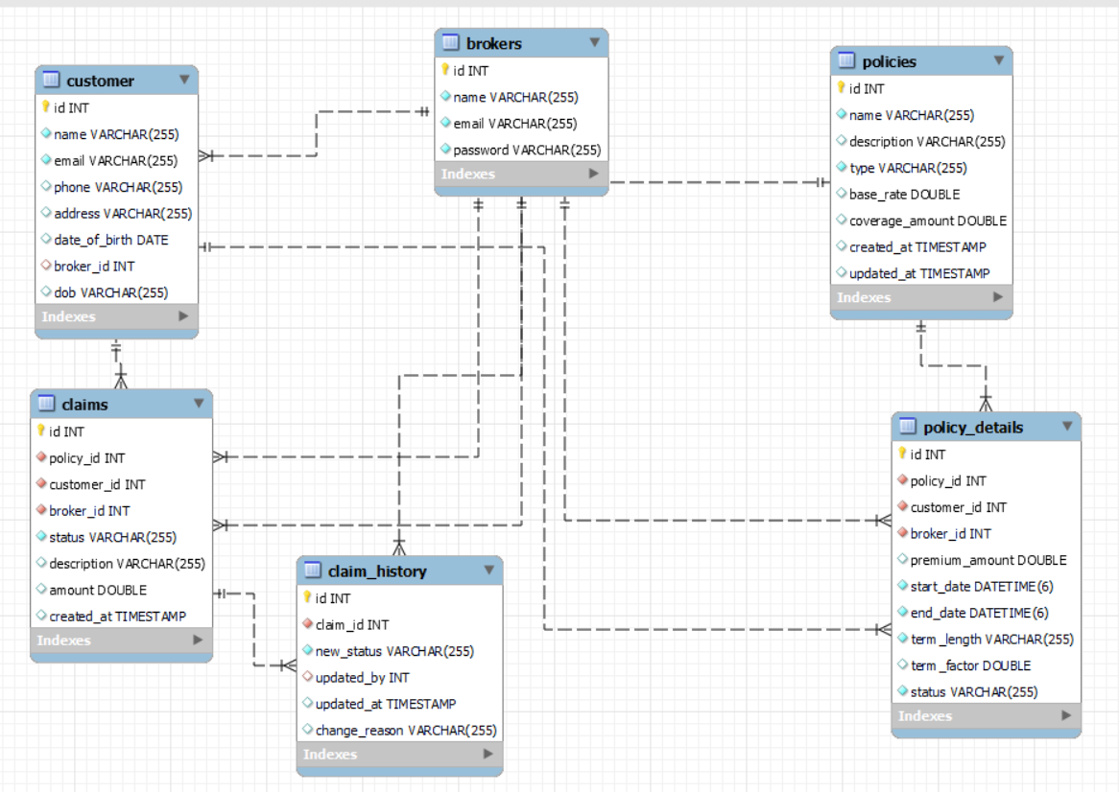

## 6.2 Relational Model

The relational model includes the following tables:

**Brokers Table**

* **Columns**: id, name, email, password
* **Description**: Stores broker credentials

**Customers Table**

* **Columns**: id, name, email, phone, address, date_of_birth, broker_id
* **Description**: Manages customer details..

**Policies Table**

* **Columns**: id, name, description, type, base_rate, coverage_amount, created_at, updated_at
* **Description**: Defines policy information.

**PoliciesDetails Table**

* **Columns**: id, policy_id, customer_id, broker_id, premium_amount, start_date, end_date, term_length, term_factor, status
* **Description**: Links policies to customers.

**Claims Table**

* **Columns**: id, policy_id, customer_id, broker_id, status, description, amount, created_at
* **Description**: Tracks customer claims.

**ClaimHistory Table**

* **Columns**: application_id, job_id, candidate_id, application_date, status.
* **Description**: Logs claim updates.

# 7. Features

* **Customer Management:** CRUD operations for customer data.
* **Policy Management:** Managing policies and linking them to customers.
* **Claims Management:** Submitting, updating, approving/rejecting, and tracking claims.

# **8. UML Diagrams**

## ****8.1 Class Diagram****

## ****8.2 Sequence Diagram****

# 9. Screenshots

**Broker registration**

**Broker login**

**Broker Dashboard**

**Add new customer**

**Assign Policy**

**Calculated premium amount for the customer**

**Submit claim**

**Claim history**

**Admin claim approval/reject**

**Claim history for broker**

**Policy Renewal**

**Expired policy**

**Policy renewed for customer**

# **10. Conclusion**

The **Insurance Broker System** provides a modern, scalable solution for managing insurance operations. By integrating advanced technologies and patterns, the project ensures data integrity, ease of use, and scalability.